App in a Day
Hands-on Lab Step-by-Step
Contents
Importing Module 1 Completed 1
Task 1: Create a new environment 1
Task 2: Import the solution 2

Importing Module 1 Completed
Follow the steps below, if you did not complete Module 1 and would like to skip to Module 2

Task 1: Create a new environment
- Open a new browser tab, navigate to Power Apps admin portal select Environments and click New Environment.
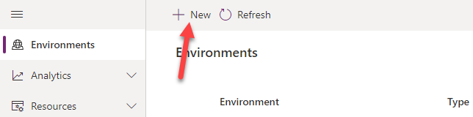
- Provide an Environment Name, select Trial for Type, select Region, select Yes, for Create a database for this environment, and click Next.
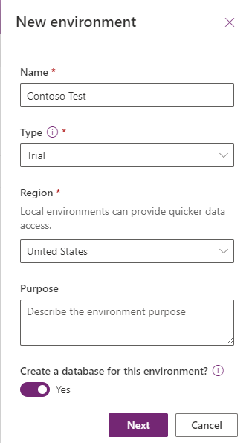
- Select Language, URL, and Currency. Click Yes for Deploy sample apps and data and then click Save.
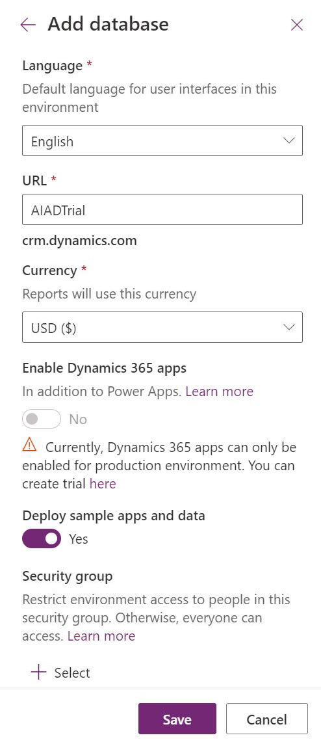
- Wait for the environment to be created.

Task 2: Import the solution
In this task, you will import the completed module 1 solution.
- Navigate to Power Apps maker portal
- Make sure you are in the Contoso Test Environment you created.
- Select Solutions and click Import solution.
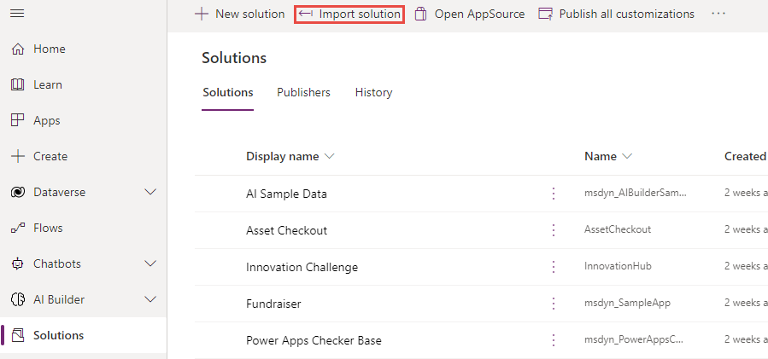
- Click Browse.
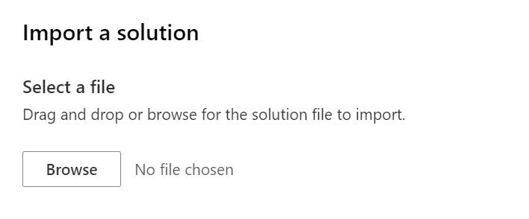
- Select the Contoso Coffee solution zip file located in Module 1 Completed folder and click Open.
- Click Next.
- Click Import.
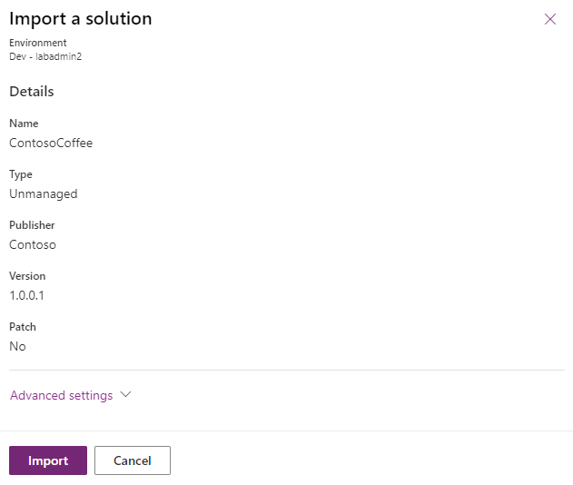
- Wait for the solution import to complete.
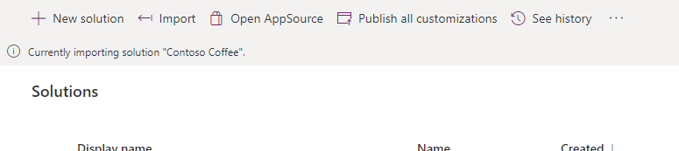
- Click Publish all customizations and wait for the publishing to complete.
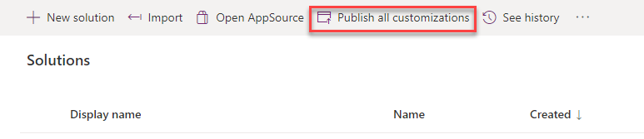
- Click Apps, click on the … button of the Machine Ordering App and click Play.
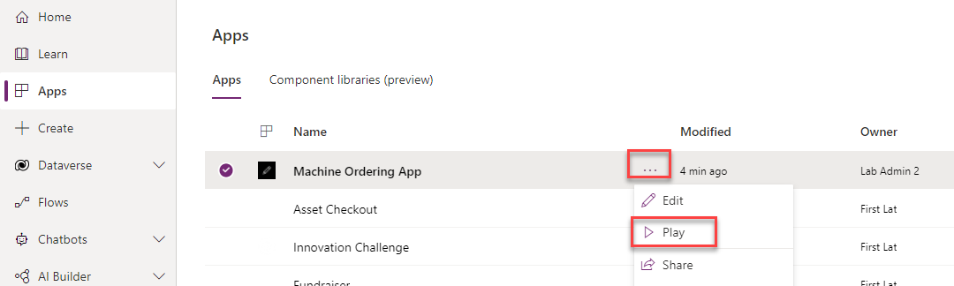
- Confirm the application loads.
